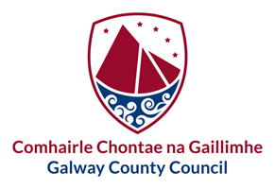
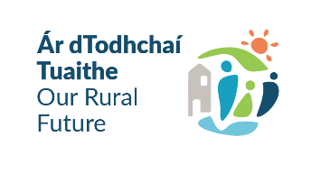
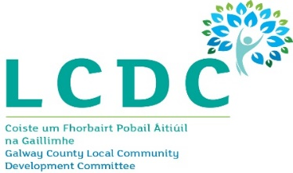

Community Recognition Fund 2024
Expression of Interest Form

The closing date for receipt of completed Expression of Interest forms to crf@galwaycoco.ie is 5pm on Friday 24th May 2024

Your completed application must include:
- Fully completed Expression of Interest Form
- Breakdown of total estimated costs supported by minimum 1 quotation.
- Up-to-date Bank or Credit Union Account Statement.
- Proof of Planning Permission or any other required consents.
- Letters of Support (optional).

Summary of Expression of Interest:
Name of Applicant Group/Organisation:

Name of Community Amenity/Facility:

Project Title (max 20 words):
(Must reflect the location of the project and the work to be undertaken to it.)
Town/Village covered in this Expression of Interest:

What continued impact has the additional numbers of New Arrivals on community amenities/facilities/services on your town/village?
What gaps in community infrastructure/facilities/amenities have been identified in your community as a result of the New Arrivals?
How will your project proposal serve the New Arrivals and your local community?

Applicant Information:
Name of Applicant Group/Organisation:
Contact Name:
Role in Group/Organisation:
Telephone Number:

Email Address:

Legal Status: (Community Group, Incorporated Cooperative / Company Limited by Guarantee, Charity, Social Enterprise)
Tax Reference Number:

Please list any additional partners to this application:
(You may wish to include Letters of Support if relevant.)

Project Information:
Project Address:  Project Eircode:  Project XY Coordinates:  https://irish.gridreferencefinder.com/ | X ITM Y ITM
Please confirm that your Project Address is located within the town/village boundaries of one of the Eligible Locations listed in the Guidelines: If you answer No, please describe how New Arrivals are utilising your Facility / Amenity on a regular ongoing basis: | Yes No
Describe your project:

What are the identified needs this project will seek to address?

How have you identified these needs in consultation with your community and/or users of your facility?
You may wish to attach/link to any Community Plan, Energy Audit, etc., as supporting documentation.

How will your project deliver tangible benefits to your community? In particular, you should address:
- Who will benefit – does the facility/amenity comply with the following County Development Plan objectives? You may wish to list the range of groups who use your facilities in providing your answer:
- Projects related to community buildings – promote multi-purpose community facilities which are open to, and used by, a broad range of individuals and groups within the local community.
- Projects related to community amenities - promote multi-functional open spaces supporting a range of recreational and amenity activities that provide for active and passive needs, and all ages & abilities.
- When they will benefit – clearly outline any restrictions on the availability of the facility/project, e.g., if it is only open to general community use at certain hours, and how this is managed.
- Extent of benefit – is usage of the facilities free of charge or subject to ongoing charges or membership fees – please give details.

Financial and Project Delivery Information:
Please breakdown your proposed project into its individual cost elements & phases:
Project Element | Estimated Cost | Estimated Completion Date
Total Costs | €
Less amount of any Match Funding if relevant | €
Total Grant Amount Sought | €

Are all relevant permissions in place for this project? (e.g., planning, environmental / ecological surveys etc. | Not applicable ☐ YES ☐ NO ☐

Please confirm that you have ownership of the facility/amenity which is the subject of your proposal. If not, please confirm there is a minimum 5-year lease in place and provide written consent from the landowner/property owner for your proposal.

Outline the capacity of your group to deliver the project as outlined, in particular, track record and experience of other similar-size projects, and your proposal for managing phased drawdowns and cashflow.

 | Is this proposal linked with an application to, or funded by, any other public funding scheme operated by Government Departments or the Local Authority? If YES please provide details: |  | Not applicable ☐ YES ☐ NO ☐
Is this proposal linked to any approved project under the Community Recognition Fund 2023? If yes, please outline how it is a separate or complementary phase if relevant. |  | Not applicable ☐ YES ☐ NO ☐

If your facility received a grant under the Community Recognition Fund 2023 which is not drawn down to date, please provide a definitive timescale for completion of same.

Declaration:
I confirm I have read and understand the DRCD Scheme Outline and Galway County Council’s Guidelines and declare that:
- The information I have given is true and correct.
- The supporting costings are accurate and reasonable.
- All necessary permissions are in place, e.g., planning consents, environmental consents, etc.
- There is evidence of ownership, or a 5-year lease and landowner consent.
- The project will comply with all Public Procurement requirements if approved.
- No funding has been allocated for the same works from any other public funding source.

Proof of all the above is not required at the time of Expressions of Interest but must be made available for all shortlisted projects.

Signed: ______________________________ Date: _______________________________
On behalf of Applicant Group/Organisation

